The Top Beauty Treatments you can do NOW for 30s and 40s…
( some are new, some are tried and true!)

Dear 30s and 40s,

It’s time to shake off the teen and 20s mindset of “I don’t have to do much to look my best”. Do you think that celebrities like Gwyneth and Jennifer are aging well? If you too want to appear to be “naturally ageless”, it will take some intelligent effort on your part. The good news is that there are effective, safe, easy, non-surgical, no downtime advancements to help you.

Body
Can you pinch an inch?

Now is a good time to correct problems that will become more difficult to fix later in life when your skin is more lax.
For example, do you have “figure faults” such as the dreaded “love handles” or a waistline reminiscent of an inner tube that have persisted despite numerous attempts to diet and exercise them away? No worries. Help has arrived!

Liposonix is the revolutionary advanced ultrasound fat reduction technology that non- invasively yet permanently destroys targeted fat. For example, a single hour of this safe sound wave treatment to your belly and love handles today yields in 3 months 1 inch of waistline reduction (which equals 1 dress or 1 pant size) on average! Outer thighs, inner thighs, upper arms and knees can also be treated.

In order to be a Liposonix candidate you must be able to pinch at least one inch of fat in the area you want treated and have a Body Mass Index under 30. Oral sedative and analgesic pre-procedure will help with procedural discomfort. Liposonix has advantages over Liposuction. For example, because Liposonix is non-invasive, you will exit the office pain free, able to immediately resume your normal life and activities and because Liosonix is non-surgical, you can expect a smooth, even result. 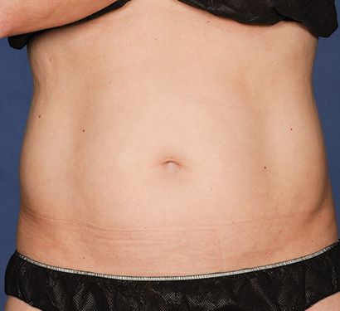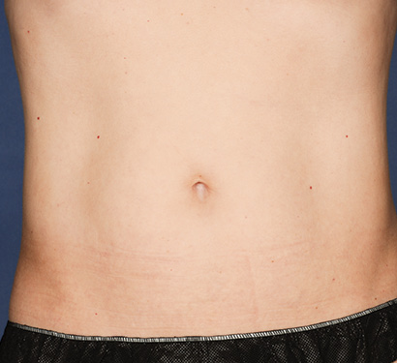

Face

Are you afraid to be seen without makeup?

If you have been naughty about limiting your sun exposure, all is not lost.
Photo Rejuvenation is an amazing no downtime method that reduces the most annoying, most common and first to appear signs of sun damage, namely brown spots and broken capillaries, enlarged pores and dull skin texture. Face, neck, chest, and arm treatment is popular and the improvement can be quite dramatic, even for the most neglected skin.

Individual responses vary mostly dependent on the patient’s starting point. Most patients leave the office pink or rosy with a smidge of puffyness. Brown spots will flake off in the center of your face in about 1 week. Those on the periphery will do so within 3 weeks.

Although Photo Rejuvenation is a tried and true method, the machines used have undergone great improvements over the years. The up to date devices are more comfortable, more powerful and more versatile than the old ones. Increased power and versatility means that more than ever the medical education, and training of the person treating you makes a huge difference in your result and safety. My personal opinion is that Photo Rejuvenation is best performed by an MD with formal skin education, training and experience.
.
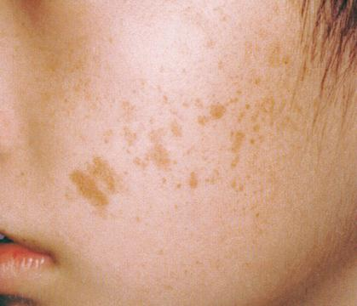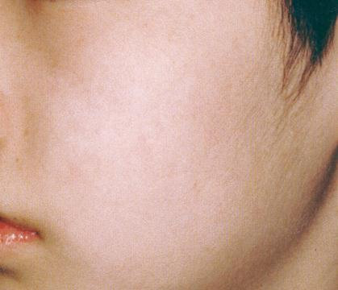

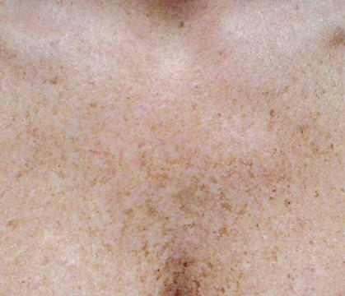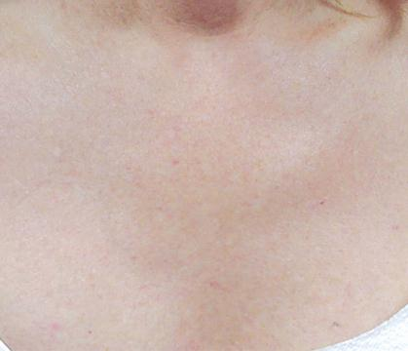

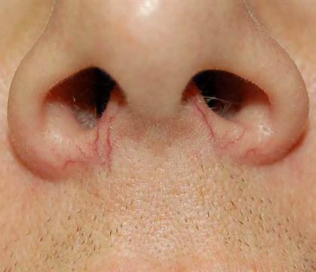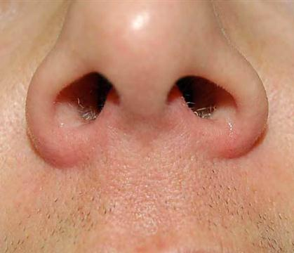

Wrinkles

Early 30s – By this time you will begin to develop your earliest problem wrinkles. These will likely be the vertical “11’s” between your brows (aka “worry lines”), horizontal forehead lines or crows feet. These lines are due to years of excessive frowning, squinting or eyebrow raising. Such furrows are not only aging, but also can falsely make you appear to be angry or tired- Yuck! Appearing to be constantly tired, tense, haggard or angry is a disadvantage in your work and personal life.

Botox is the prime treatment for these upper face movement lines and will likely be your first in-office wrinkle intervention therapy. Most women request treatment for these by their early 30s. I have had many young teachers and young mothers seek Botox treatment exclaiming that “My students/children think I am angry, but I am not!”

After Botox you usually will leave the office with a bit of pinkness and the injection sites. For 4 hours post Botox do not touch the sites or hang your head down.

Mid 30s- By this time you will be annoyed by additional wrinkles such as deep under eye creases, marionette lines, and smile lines. Dermal Fillers such as Juvederm, Restylane, Belotero, and sometimes Radiesse are standard options for these wrinkles. These substances are injected, usually in the dermis of the skin to support and fill the collapsing wrinkle skin.

Botox and fillers are the #1 and #2 most popular cosmetic therapies in the U.S. And for good reason, these injectable “lunchtime” treatments can yield dramatic albeit temporary improvement without surgery. Temporary bruising is a common consequence of filler injections.

Botox and filler treatment may seem to the casual observer to be simple to perform but in fact there are often complexities to consider. That is why, in my opinion, it is important that the individual who actually performs your injection possess formal medical education, training and experience of significant depth and breadth. This includes knowledge of general medicine, facial anatomy, aesthetics, the science of collagen formation, product pharmacology and potential medication reactions.
Why would you potentially jeopardize your result by employing someone who lacks the detailed knowledge that could mean the difference between an okay result and an exceptional one? Why would you potentially jeopardize your health by employing someone who lacks the medical training that would be necessary to notice an occult skin
issue you might unknowingly have?

The home front

Noticeable nicer skin in 2 weeks!

Call me bossy if you like, but I will tell you straight.
You should ALL be using what I call THE BIG 3 of home care products:

1) Retinol
Aside from sunscreen, retinoids are the most proven effective anti skin aging substance. Retinol is my preferred retinoid as it successfully balances effectiveness with gentleness. Select a product such as Retinol Plus Smoothing Serum that lists the concentration of its active ingredient. I suggest my patients use the 10X or 15 X concentration 3 nights per week.
2) Antioxidant
My favorite antioxidant is CF Cream. In fact it is my favorite skin product of all time. It is a soothing and beneficial blend of ingredients including green tea and resveratrol which I apply each morning underneath my tinted moisturizing chemical free SPF 30 sunscreen. I don’t even need moisturizer or makeup with this morning system!
3) L-Ascorbic Acid (Vitamin C family)
Beware! Not all vitamin C related skin products are created equal. They are all finicky and difficult to keep stable when formulated into a skin product. Plus, some Vitamin C related compounds are inherently less effective than others. I prefer Citrix. This product respects the finicky nature of this family of substances. Apply L- ascorbic 3 nights per week.
Of course, the sine qua non of any anti-aging skin regimen is routine use of
SPF 30 or greater sunscreen.

Tweak your makeup!

Its time for more than just lip gloss and mascara.

Sabetta’s Selections for 30s and 40: Highlighting and Contouring.

Try Nars, Highlighting Stick in Copocabana to accent temples and other receding facial areas.

Try Kevin Aucoin’s The Sculpting Powder under your cheekbones and jawline to create a more sculpted look.

Highlighting and Contouring can be your best friend whether preparing for a candlelight dinner, an evening by the fire, or family photos!

Enjoy,
Happy Holidays

Febuary is moisturizer time. What is your favorite moisturizer?

